EXERCISE 8.3

Question 1:

Express the trigonometric ratios sin A, sec A and tan A in terms of cot A:

Solution:

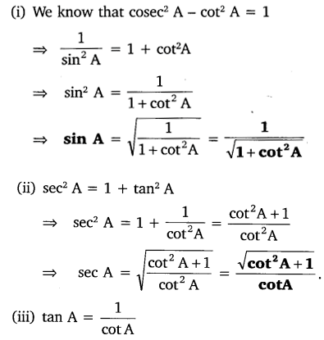

Question 2:

Write all the other trigonometric ratios of ∠A in terms of sec A.

Solution:

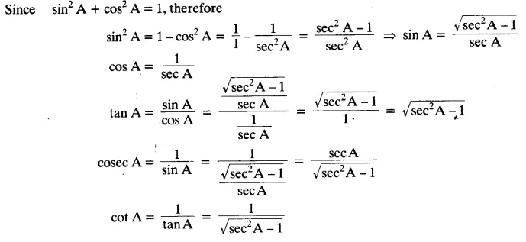

Question 3:

Evaluate:

NCERT Solutions For Class 10 Maths Chapter 8 Introduction to Trigonometry Ex 8.4 Q3Solution:

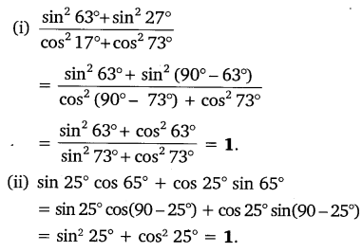

Question 4:

Choose the correct option. Justify your choice.

(i) 9 sec² A – 9 tan² A = ……  
(A) 1  
(B) 9  
(C) 8  
(D) 0

(ii) (1 + tan θ + sec θ) (1 + cot θ – cosec θ) = ………..  
(A) 0  
(B) 1  
(C) 2  
(D) -1

(iii) (sec A + tan A) (1 – sin A) = ………….  
(A) sec A  
(B) sin A  
(C) cosec A  
(D) cos A

(iv) 1+tan2A/1+cot2A = ………..  
(A) sec² A  
(B) -1  
(C) cot² A  
(D) tan² A

Solution:

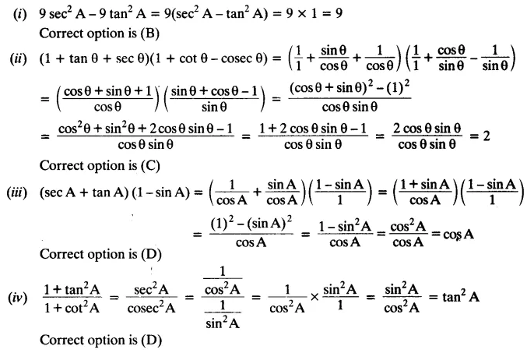

Question 5:

Prove the following identities, where the angles involved are acute angles for which the expressions are defined.

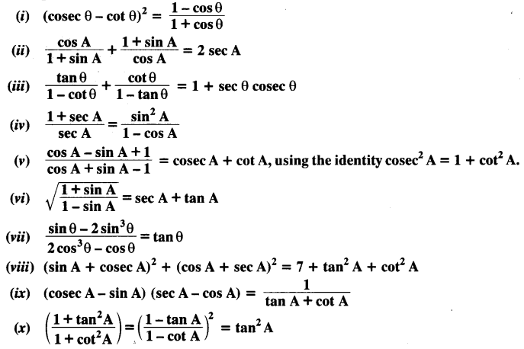

Solution:

